Archi - ArchiMate Modelling

What’s New in Version 1.6

Important Note
It is always a good idea to make backup copies of your data before installing a new version of Archi. Whilst we make every effort to test the software and check for bugs we cannot guarantee that bugs do not exist in the application nor that your data might be affected by changes in this version of Archi. Please backup your data first!

New Features
- Format Painter
- The "Automatic Relationship Management" system (ARM)
- Import BiZZdesign Architect models
- Export model to CSV format
- Added Help files and contextual Help support to Help system
- Multi-line text controls in the Properties window now support hyperlinks
- Can now set the line colour for connections
- Business, Application and Infrastructure Interface element types now have "provided" and "required" properties
- Ctrl key and mouse scroll wheel zooms the diagram
- Middle mouse button activates the Pan control
- Improved layouts of the Properties window's sections
- Support for 3rd party import/export plug-ins
- Improved and more informative tooltips in Views
- Added a preference to not show tooltips in Views
- Added 25% Zoom factor to Zoom control
- The ArchiMate type for a selected object is shown in parentheses in the title of the Properties window
- Animation on undo/redo now works for Mac Cocoa version

Fixes
- Fixed drag and drop not working on Mac 64-bit version
- Fixed an issue where it was possible to drag the wrong type of palette entry to an incorrect type of View
- Fixed Properties window not updating on Mac Cocoa version
- Undo/Redo menu items are now active when the Navigator has focus
- Navigator now updates in response to relationship connection changes
- Fixed regression bug introduced in 1.5 where Zoom menu items stopped working
- Pasting copied objects in a View is now faster
- Fixed title bar in the Properties window not displaying the "&" character
- The Note figure now has a sensible default size
- Structural Chains (Derived Relations) are highlighted with a thicker red line
- Fixed figures losing their default width and height (-1) when moving them to a parent figure
- Fixed Hints View not updating on Magic Connector menu rollover on Mac OS X
- Internal optimisations

The Format Painter
The Format Painter is a tool on the Palette toolbar that allows you to quickly copy the visual formatting of one element or connection and paste it to others in a View. Instead of having to manually apply the font, font colour, text alignment, and other formatting to each new element or connection in a View, you can quickly copy all of the formatting attributes by using one toolbar button.
The Format Painter tool is at the top of the Palette:
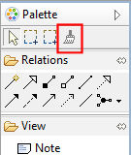
The Format Painter
To copy and paste formatting in View:
- Select the Format Painter tool from the Palette. Initially it will appear grey, indicating that it is "empty" and ready to copy.
- Click on the source element or connection from which you wish to copy the formatting. The Format Painter tool cursor will change to a darker outline and to the colour of the fill element or connection that is copied. Also, the tool entry on the Palette will appear darker and the tooltip will update to explain this.
- Now click on the target elements or connections to paste the formatting.
- To clear the Format Painter so it is ready to copy some more formatting, either double-click on the tool in the Palette or double-click on an empty space on the canvas.
Note that copied formatting from an element cannot be pasted to a connection, and vice-versa. You can use the Format Painter tool between different Views. If it is "primed", simply select it from the Palette in another View and paste the formatting to target elements or connections.
To see a screen-cast demonstration of the Format Painter go to this web-site: http://archi.cetis.ac.uk/movies/format-painter/format-painter.html

The "Automatic Relationship Management" System (ARM)
Each graphical element (except for notes and junctions) can act as a container element for other elements. Dragging and dropping an element inside of another element means that it becomes a child of the parent element. This is useful to represent containment type relationships such as Composition, Aggregation, and Association or for convenient grouping.
In the following screenshot the elements "Register", "Accept", "Valuate" and "Pay" are child elements of the parent "Handle Claim Process" element:
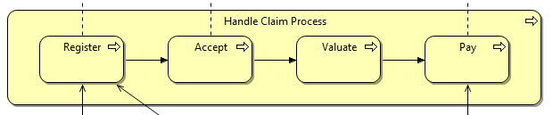
Child elements contained by a parent element

While dragging elements into or over other elements a visual cue is provided to indicate that the dragged element will be moved into the parent (container) element. This is a blue highlight around the target element as the element is dragged over it:
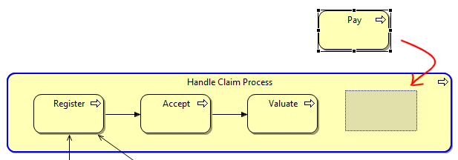
A Child Element being Dragged into a Container Element. The Container highlighted in blue

Creating, Showing and Hiding Relationships between Nested Parent/Child Elements
The ArchiMate specification states that the relationships Composition, Aggregation and Association may also be expressed by nesting the model elements. That is to say, an explicit connection need not be drawn between the parent and child elements but that they may be drawn as a container nested type instead.
Archi supports this convention with Automatic Relationship Management (ARM). This system ensures that relationships are automatically created and hidden between qualifying parent/child elements. The system can be configured to suit the user's needs. See Preferences to configure the ARM.
The best way to explain the Automatic Relationship Management system (ARM) is by an example.

Example - Nested sub-processes in a Composite relationship
Suppose the user has a Business Process element named "Handle Claim Process" that will act as a container element ("parent") for four sub-processes, "Register", "Accept", "Valuate" and "Pay". The relationship between the parent process and the sub-processes would normally be expressed as four Composition relationships. These can be drawn conventionally using connecting lines as follows:
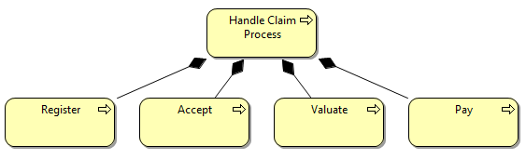
Composition relationship between parent and child processes
However, this is visually not as clear as if the sub-processes were placed inside of the container parent process. Unfortunately, simply moving the elements into the parent results in a mess:
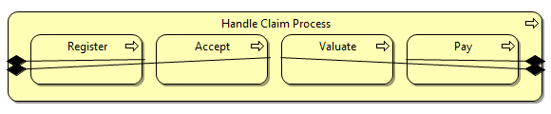
Messy arrangement of explicit connections
In order to tidy up this arrangement we need to delete the four Composition connections. We cannot delete the Composition relationships from the actual model as this would mean that it is not semantically correct. We could delete the connections from the View (the "Delete from View" command) which would leave the relationships in the model, but then the "Analysis" Properties table would not show that the relationships were used in this View (they would display in an italic font in the Model Tree, see "Elements in the Model Tree and Views")
We can solve this problem by enabling the ARM system in Preferences. This ensures that when the sub-processes are placed in the parent element the connections are hidden in the View, but are still regarded as present in the View in the "Analysis" table of the relationship's properties. Dragging the child elements in and out of the parent element hides and then shows the explicit connections. We regard the hidden connections as "implicit" connections.
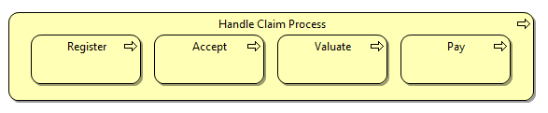
The Connections now hidden from the View

Adding new elements to a parent element
Adding new elements to a parent element in a View from the Palette or dragging and dropping from the Model Tree results in a dialog box asking if a new relationship should be created between the parent and child elements:
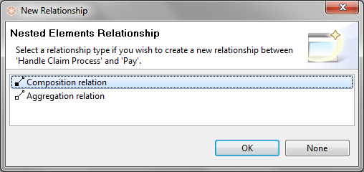
Dialog to create a new nested relationship
Note that the dialog will only display valid relationships between the parent and child elements, and only those that are specified in Preferences. If you do not wish to create a new relationship, select "None".

Moving existing elements to a parent element
If more than one element is moved (drag and drop operation) to a parent element in a View or is dragged and dropped from the Model Tree onto a parent element, and there are no existing preferred relationships between the parent and the child elements then a dialog box is displayed offering to create new relationships between the parent element and the child elements. You can choose a different type of relationship for each child element:
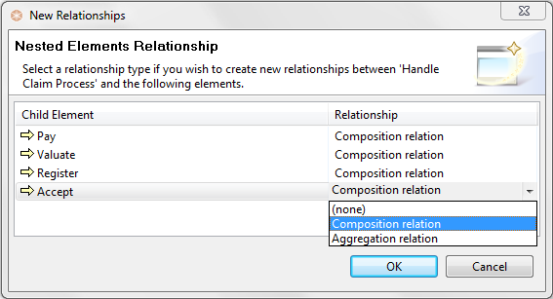
Dialog for creating more than one relationship
If you do not wish to create a new relationship for an element, select "(none)" from the drop-down combo box. To select the same type of relationship in the drop-down combo-box, hold down the Ctrl / Command key and select.
If the "Link to View" button is enabled in the Model Tree and you select a relation in the Tree then normally the corresponding connection is selected in the View, but in the case of an implicit type connection (hidden) then the parent and child elements are selected in the View to show that relationship.

ARM Preferences
The ARM can be configured extensively in Preferences:
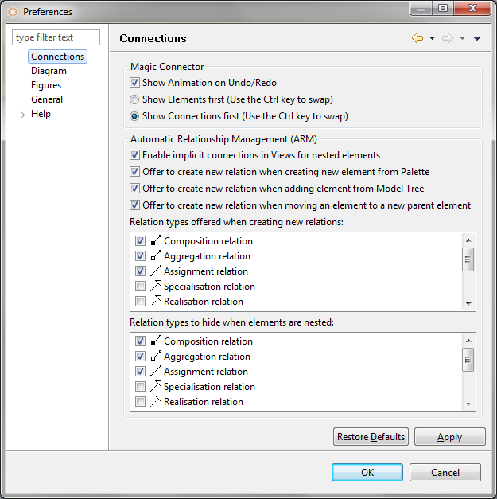
Preferences for the ARM system

To see a screen-cast demonstration of the Automatic Relationship Management (ARM) system go to this web-site: http://archi.cetis.ac.uk/movies/nested-relations/nested-relations.html

Import BiZZdesign Architect Models
You can now import model’s created in BiZZdesign Architect.
To import a BiZZdesign Architect Model select the menu item "File->Import->BiZZdesign Architect Model..." and choose an "*.XMA" file from the file selection dialog. Alternatively, you can simply drag and drop the "*.XMA" file from the desktop onto a blank area of the Model Tree.
Note that some features of BiZZdesign Architect are not supported in Archi and do not get imported. These include Profiles and some elements such as Goal, Principle and Guideline. Once these concepts are supported in Archi they will import correctly. Connection bend-points are not imported and recursive relationships are not supported.

Export Model to CSV format
You can now export Archi models to CSV (Comma Separated Values) format.
This option is available from the "Export Model To CSV..." menu item from the main "File->Export" menu. Once a model is selected in the Model Tree or in a View this menu item is enabled. Provide a filename to export the file in CSV (Comma Separated Values) format.
The CSV field format is as follows:
"Type", "Element name", "Documentation", "Source type", "Source name", "Target type", "Target name"
Elements and Relationships are exported. The last four fields only apply to the Relationship type. For an element they are left blank.

Added Help files and Contextual Help support to Help system
Help files are now accessible from the “Help” menu. This is a fully featured Help system with search and bookmarking. “Dynamic” help is also available providing Help based on what is selected in the Application.

Multi-line text controls in the Properties Window now support Hyperlinks
URLs that start with "http://" "https://" or "ftp://" will show as a hyperlink. Pressing the Ctrl / Command key will change the cursor to a "hand" cursor and you can open the link in a Browser.
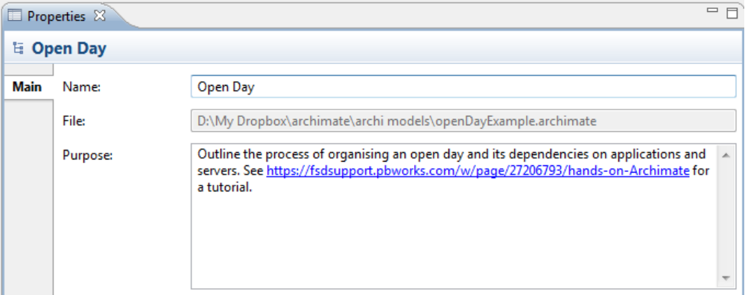

Can now set the line colour for connections
Line colour can be set for connections:
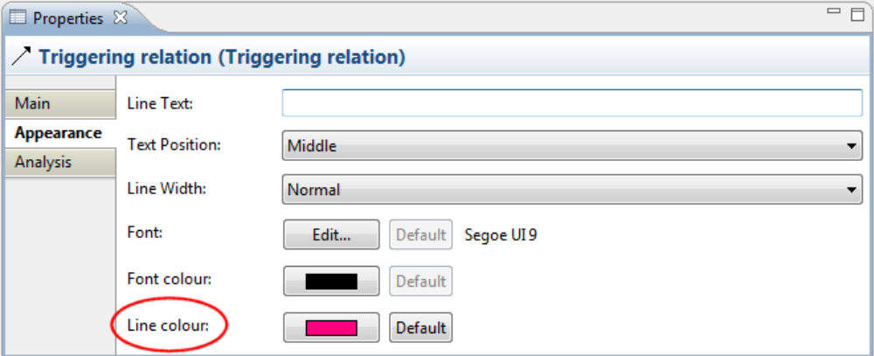

Business, Application and Infrastructure Interface element types now have "provided" and "required" properties
The Business Interface, Application Interface and Infrastructure Interface element types have an additional property:
Interface Type: | Can be set to "Provided" or "Required". Setting this also changes the element's icon.
